**ЛАБОРАТОРНАЯ РАБОТА №8**

Методы решения сетевых задач.

Автор работы

студент 2 курса

группы ИВТ(1) подгруппы 2

Ефимова В.С.

**Задание 1.**

**Постановка задачи:** Найдите минимальный остов дерева представленного графа.

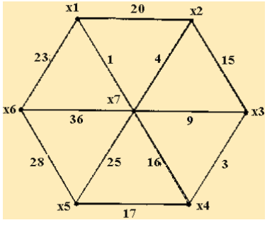

**Решение задачи:**

|  |  |  |  |  |  |  |  |
| --- | --- | --- | --- | --- | --- | --- | --- |
| Пункты | X1 | X2 | X3 | X4 | X5 | X6 | X7 |
| X1 |  |  |  |  |  |  |  |
| X2 | 20 |  |  |  |  |  |  |
| X3 |  | 15 |  |  |  |  |  |
| X4 |  |  | 3 |  |  |  |  |
| X5 |  |  |  | 17 |  |  |  |
| X6 | 23 |  |  |  | 28 |  |  |
| X7 | 1 | 4 | 9 | 16 | 25 | 36 |  |

Исключаем пути:

x1 -> x2 (x1 -> x7 -> x2 = 5; 5 < 20)

x2 -> x3 (x2 -> x7 -> x3 = 13; 13 < 15)

x4 -> x7 (x4 -> x3 -> x4 = 12; 12 < 16)

x6 -> x7 (x6 -> x1 -> x7 = 24; 24 < 36)

|  |  |  |  |  |  |  |  |
| --- | --- | --- | --- | --- | --- | --- | --- |
| Пункты | X1 | X2 | X3 | X4 | X5 | X6 | X7 |
| X1 |  |  |  |  |  |  |  |
| X2 | ~~20~~ |  |  |  |  |  |  |
| X3 |  | ~~15~~ |  |  |  |  |  |
| X4 |  |  | **3** |  |  |  |  |
| X5 |  |  |  | **17** |  |  |  |
| X6 | **23** |  |  |  | ~~28~~ |  |  |
| X7 | **1** | **4** | **9** | ~~16~~ | ~~25~~ | ~~36~~ |  |

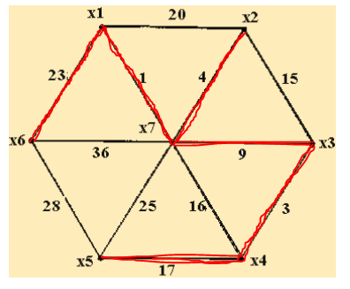

Длина минимального остова равна 23+1+4+9+3+17=57

**Задание 2.**

**Постановка задачи:** Найдите кратчайший путь на представленном графе.

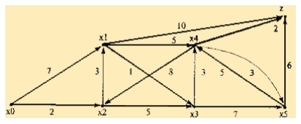

**Решение задачи:**

|  |  |  |  |  |  |  |  |
| --- | --- | --- | --- | --- | --- | --- | --- |
|  | X0 | X1 | X2 | X3 | X4 | X5 | Z |
| X0 |  | 7 | 2 |  |  |  |  |
| X1 |  |  |  | 1 | 5 |  | 10 |
| X2 |  | 3 |  |  |  |  |  |
| X3 |  |  |  |  | 3 | 7 |  |
| X4 |  |  | 8 |  |  |  | 2 |
| X5 |  |  |  |  | 5 |  | 6 |
| Z |  |  |  |  |  |  |  |

Исключаем путь x1 -> x4 (x1 -> x3 -> x4 = 4; 4<5)

|  |  |  |  |  |  |  |  |
| --- | --- | --- | --- | --- | --- | --- | --- |
|  | X0 | X1 | X2 | X3 | X4 | X5 | Z |
| X0 |  | ~~7~~ | **2** |  |  |  |  |
| X1 |  |  |  | ~~1~~ | **5** |  | 10 |
| X2 |  | **3** |  |  |  |  |  |
| X3 |  |  |  |  | 3 | 7 |  |
| X4 |  |  | 8 |  |  |  | **2** |
| X5 |  |  |  |  | 5 |  | 6 |
| Z |  |  |  |  |  |  |  |

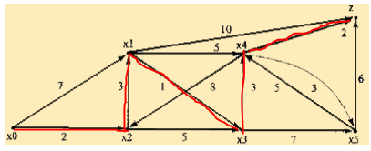

Кратчайший путь равен 2+3+1+3+2=11